# 1.Basic docker commands

To se what and all images are running

Use command 🡪 **“docker container ls”**

### Below is Command to download docker image

If image is not available locally, then only it will download, every image will be having an image id

**docker run in28min/…..**

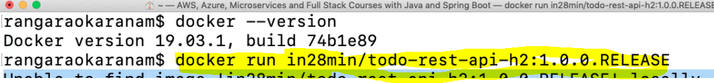

1. Running docker on 5000 port

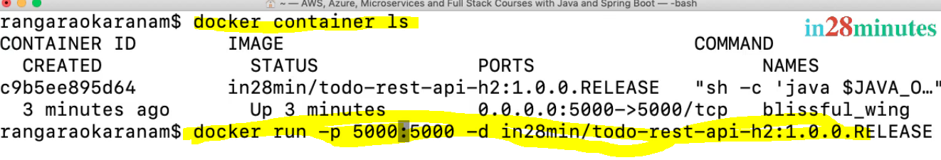

See all local docker images

* To see what and all images are downloaded run below command

**docker images**

* To see all running container and stopped containers



* **Stopping the container**

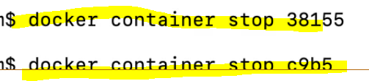

Where 38155 is the container id

See Docker image history

Where f8049a0 is the image id



And you can inspect by using docker image inspect

Remove local docker downloaded image

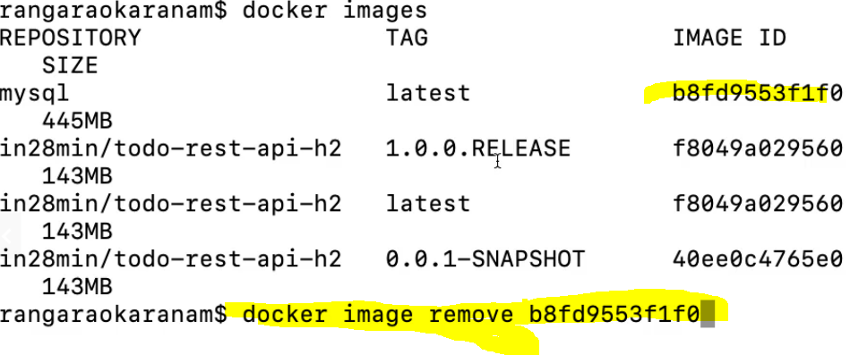

Number b8fd9 … is the local docker image id

Pausing,unpausing,inspecting contianers

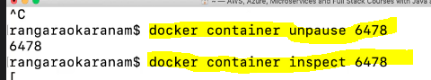

How to see the logs

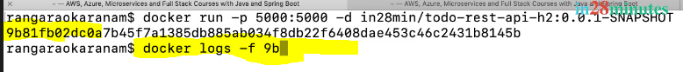

Stopping the container

Never kill the container , let it stop gracefully , using stop command

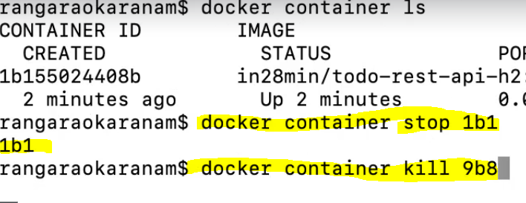

Remove all the stopped containers

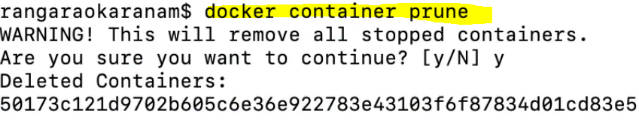

## Docker architecture

Docker daemon is responsible for pushing our local images to the repository

It will only pull the images to the remote repository

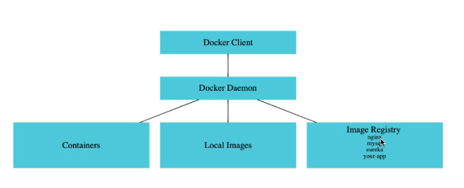

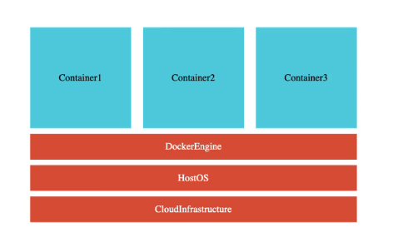

Docker advantages

With docker u don’t need java 11 nothing, straightaway give the image, that image only will download java11,tomcat,code also

All containers will be having same os. If u pull the image the os,program,dependent tomcat,java11 everything will be downloaded

### Problem with vms

Main diff between docker and vm is , every vm will be having separate os, whereas in docker

In vm concept, we will have 2 os, main os and each vm will have guest os also which makes

Vm mores bulky

